**Email Notification Ci Cd Lab**

Step 1: Install and Configure Email Notifications in Jenkins

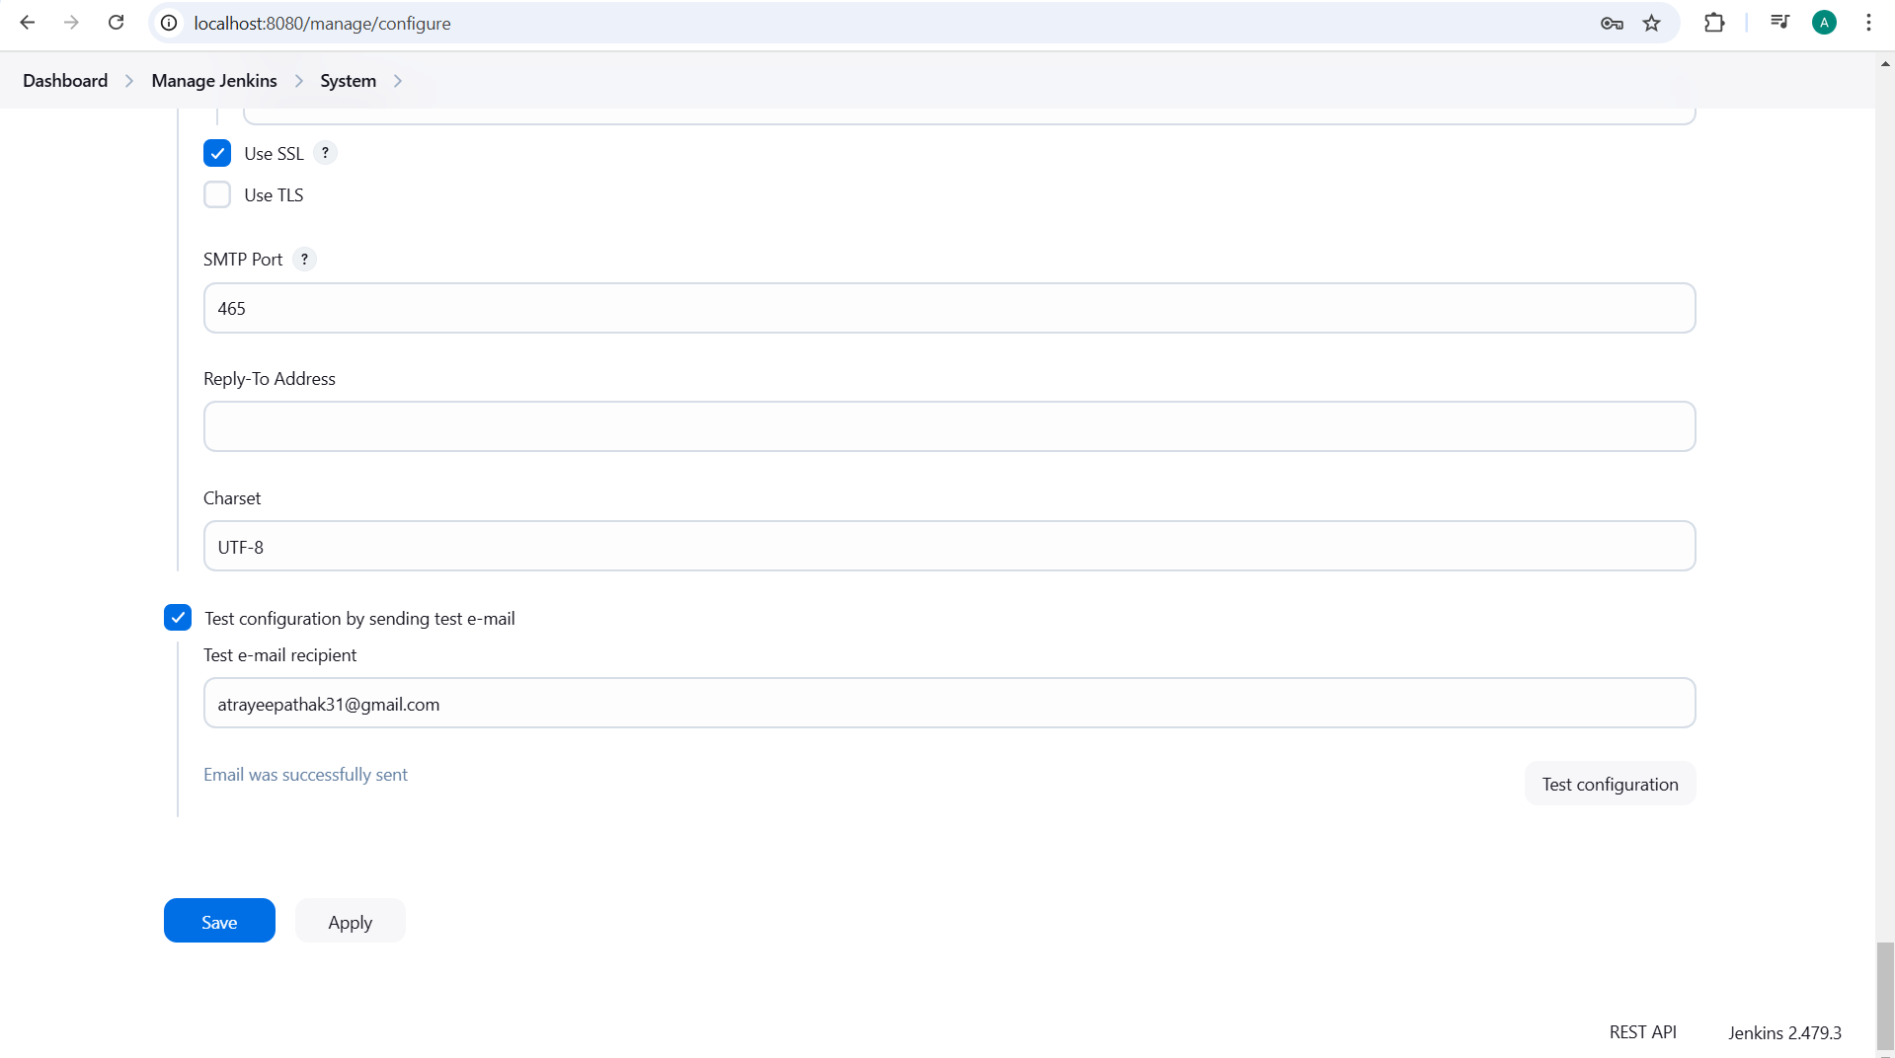

Mail is working

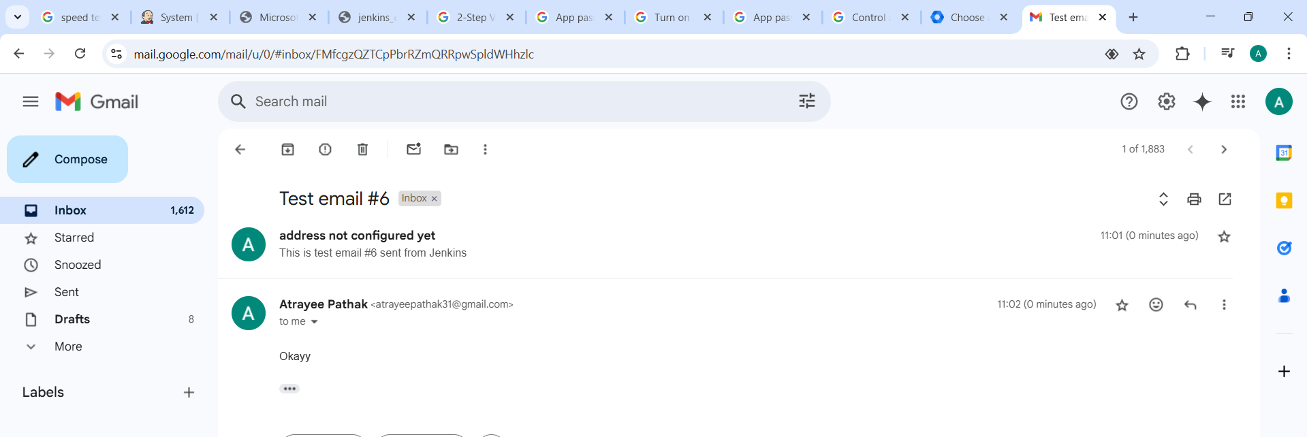

Create a New Freestyle Jenkins Project

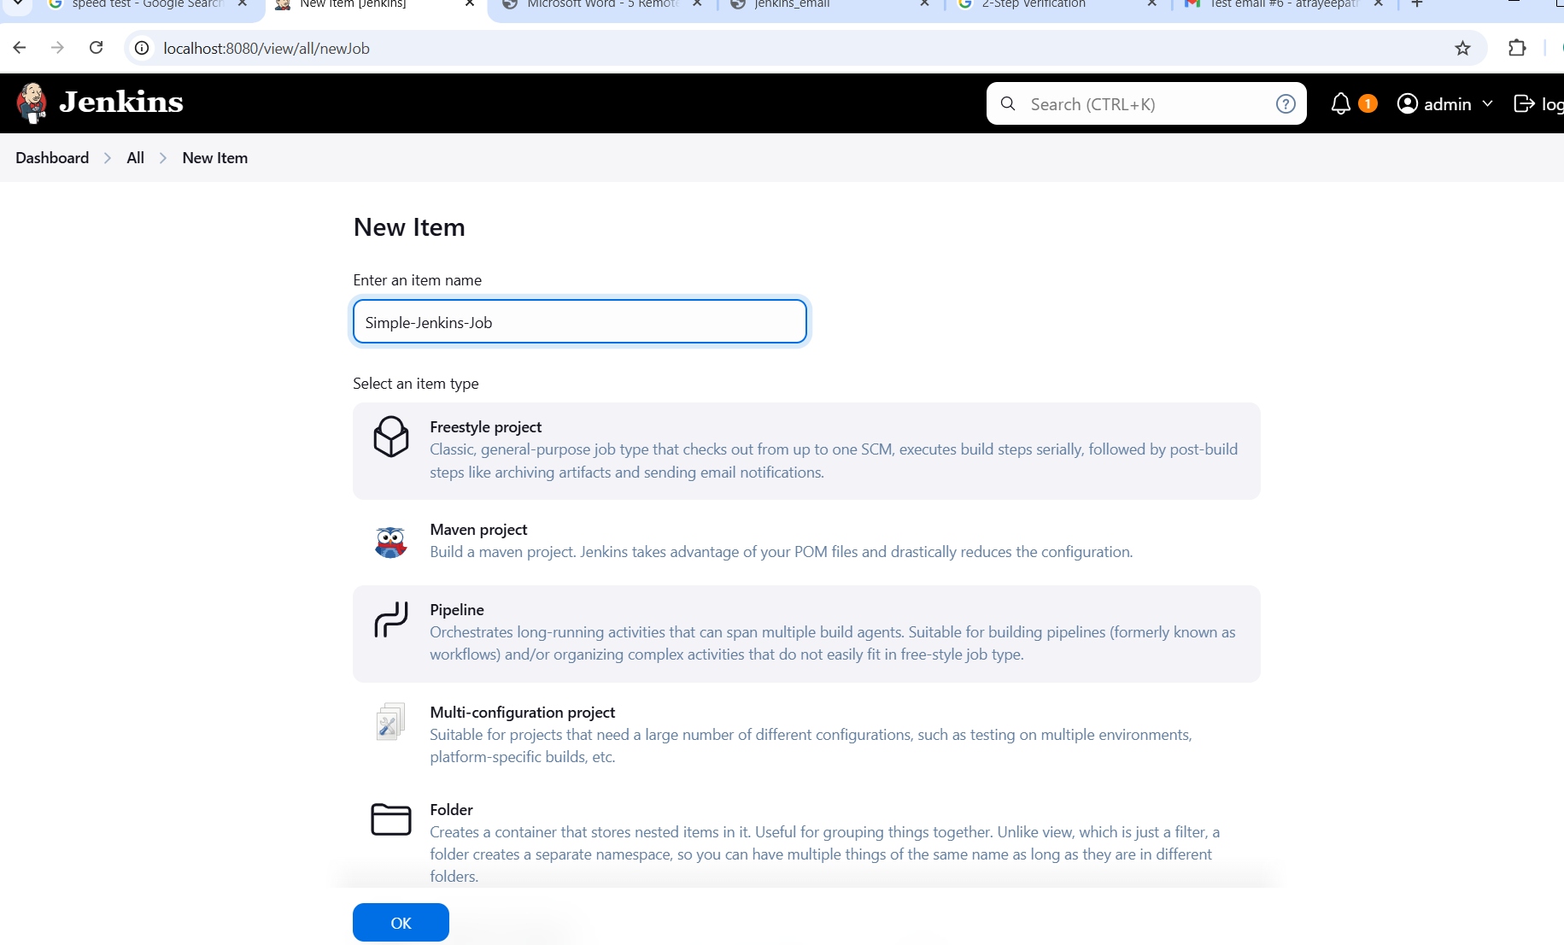

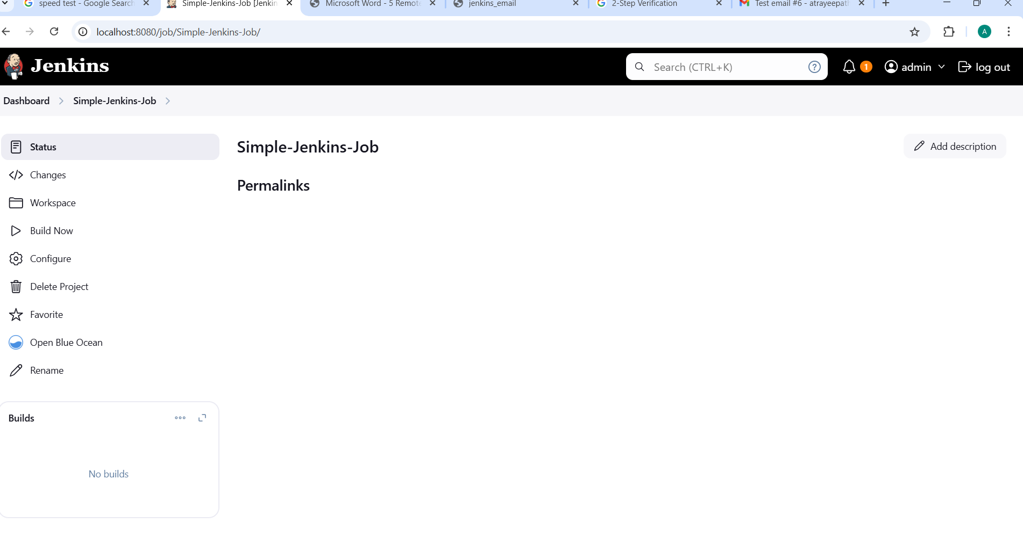

Downlaod Email Extention

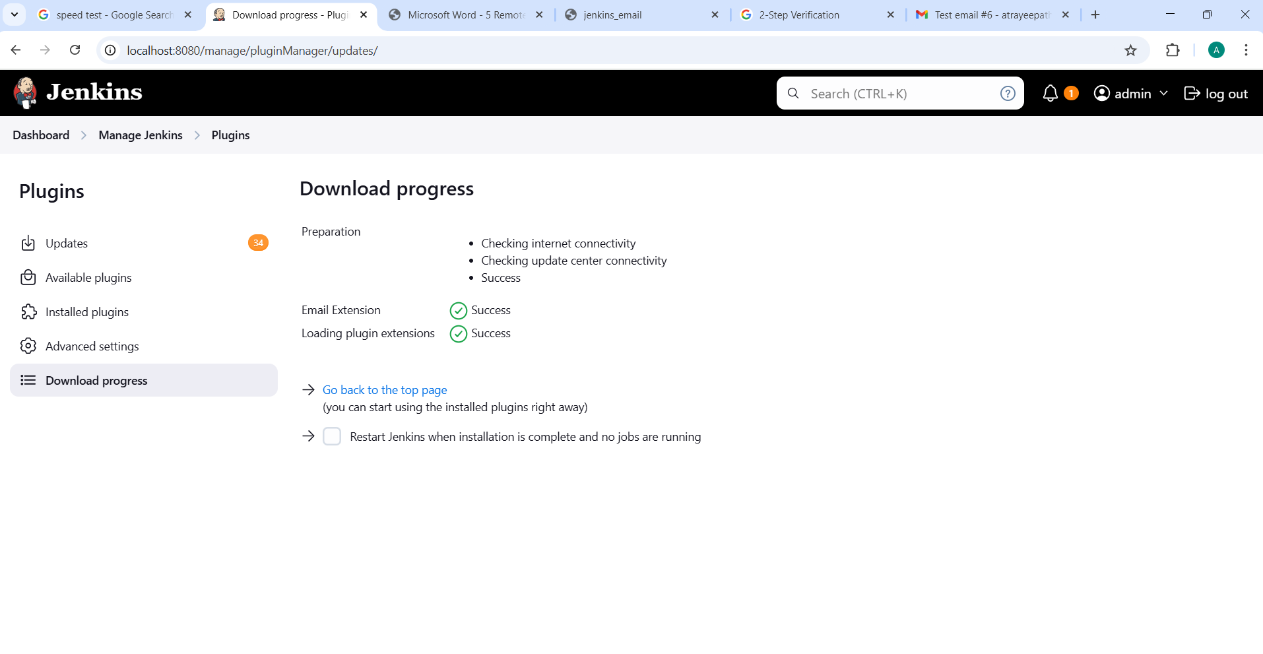

Step 4: Configure Post-Build Actions (Email Notifications)

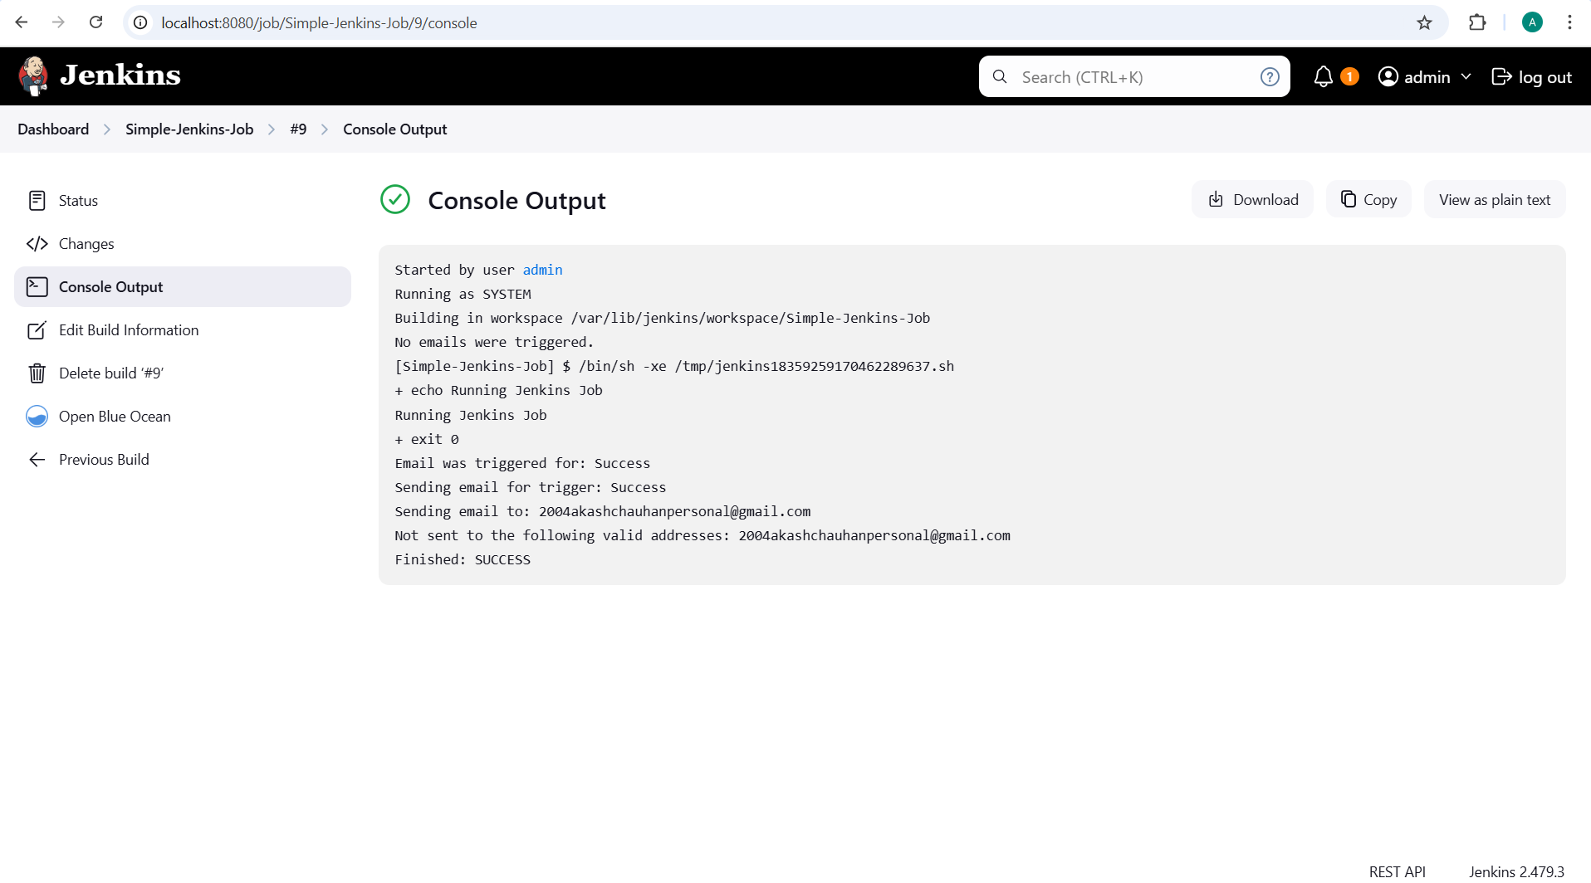

Email send to Sumit Sir

